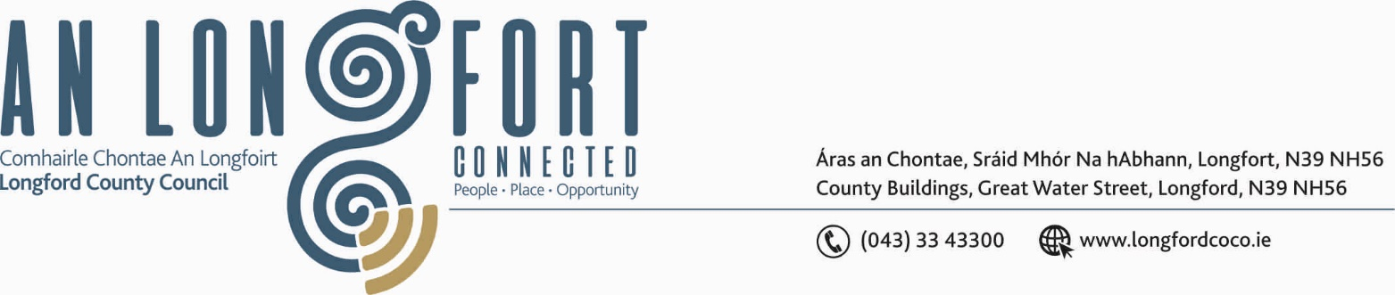

GRANARD MUNICIPAL DISTRICT

Corporate Affairs,
Aras an Chontae,
LONGFOIRT.

18th September 2019.

To: Each Member of Granard Municipal District.

Dear Member,

You are requested to attend Meeting of Granard Municipal District to be held in
Granard Community Library on Tuesday, 24th September 2019 at 3.00 p.m. to transact business, as set out on the Agenda hereunder.

Yours sincerely,
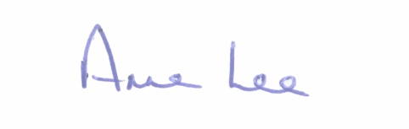

_______________
Anne Lee,
Meetings Administrator.

AGENDA

Prayer before meeting.

1. Confirmation of Minutes of Municipal District Meeting held on the
23rd July 2019 - copy enclosed

2. Matters arising from Minutes.

3. Declaration of Interest by Members.

4. Area Engineer’s Progress Report.

5. Update on Granard Public Art Features.

6. Broadband Connection Points.

7. Review of Standing Orders - draft enclosed

8. Notices of Motions, submitted by Councillors, as listed hereunder –

Councillor P.J. Reilly.

“That Granard Municipal District write to Irish Water regarding the serious situation in the Toneywarden/Ardnagullion/Feriskill area regarding the lack of supply of water over the past two summers - funding required to replace pipeline.”

Councillor Turlough McGovern.

“That through Climate Action funding, two electric charging hubs be included in the redevelopment of the parking proposals in Granard.”
“That signage for Bunlahy Bridge be in line with Purth cross i.e. rumble strips, traffic calming etc.”
“That funding be sourced for a playground for the Beechwood Estate in Granard.”



